4 CrownJewel_1

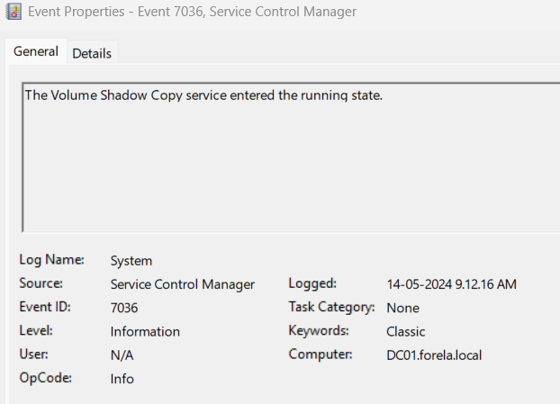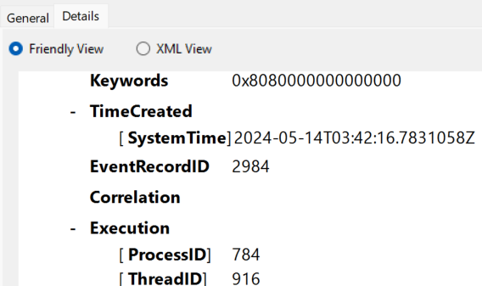

Time when the shadow copy function started
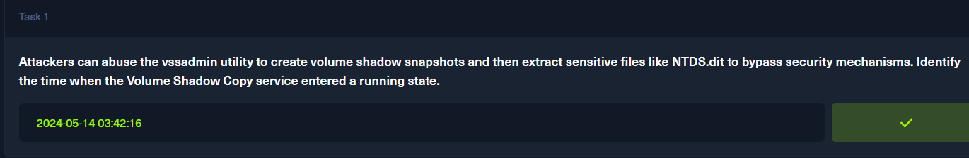

To check for the credentials enumeration I checked for the Security group management
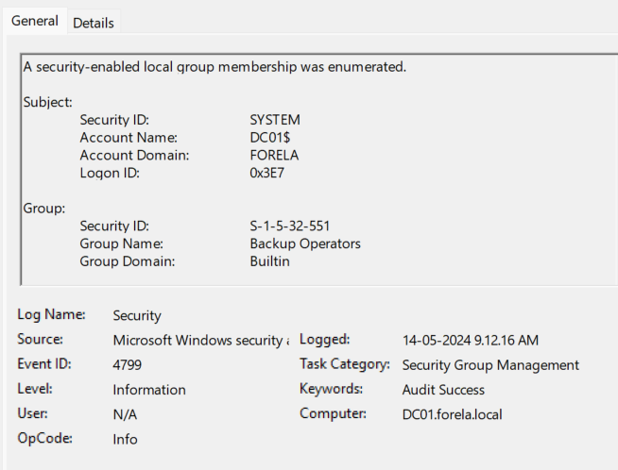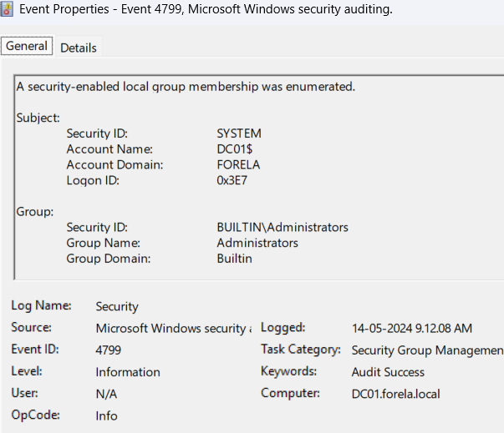
They both are enumerated by the DC01$
The groups are Administrators, Backup operators

The value of processid in hexadecimal is 0x1190 I coverted it to decimal

4496
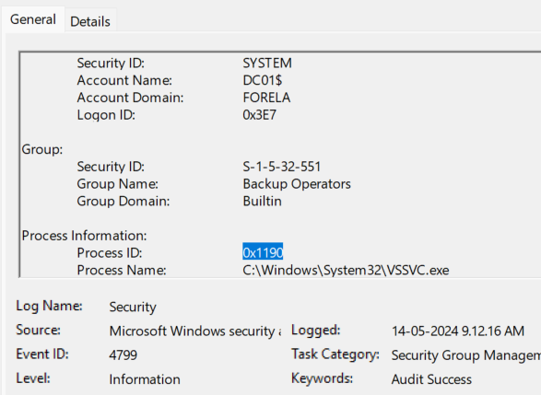
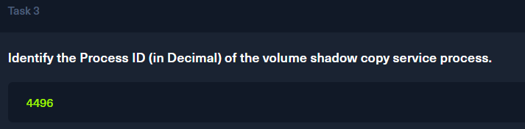

For finding the mount we get to know that in the Microsoft-Windows-NTFS
Here the event id related to 4 are the mount request. And for the attackers mount we have to find the mount related to that time that we observed in the upper questions
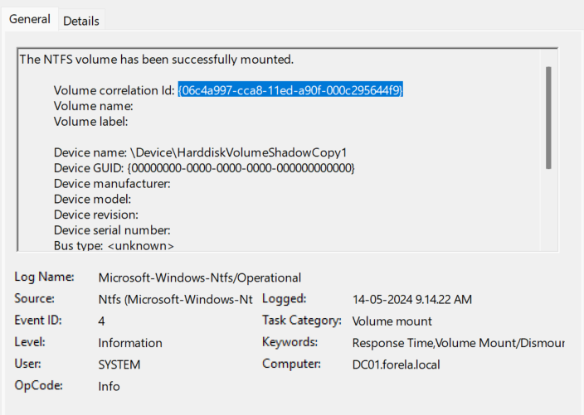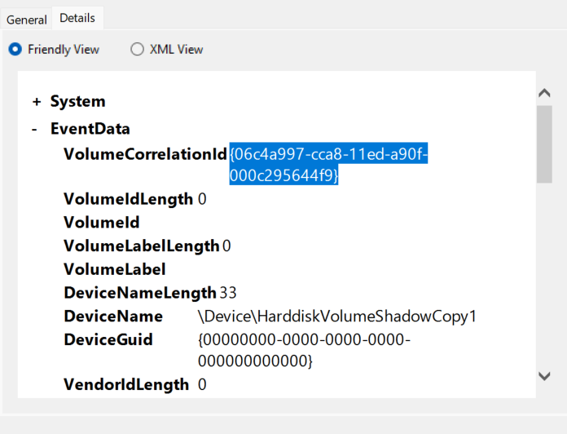
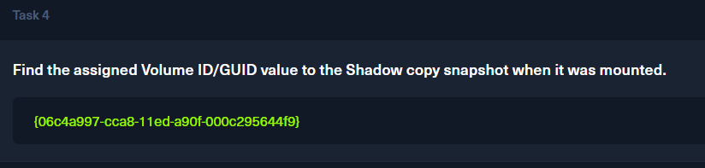

For the next question w need to use a tool name MFTECmd you can download it from here
https://ericzimmerman.github.io/#!index.md
Then we need to extract the file and also copy the MFT file present in the c file inside the artifacts given to you the use the below command in windows cmd
MFTECmd -f $MFT --csv . --csvf CrownJewel1-MFT.csv
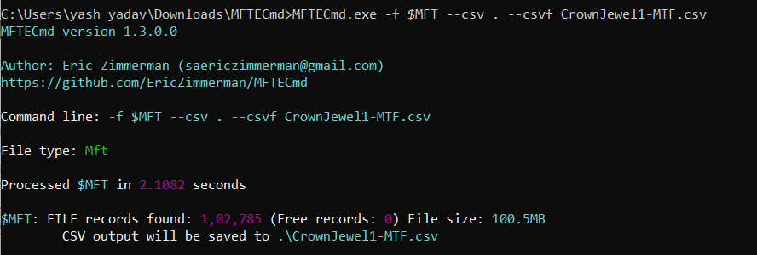
Then we will get the file in a readable format of csv
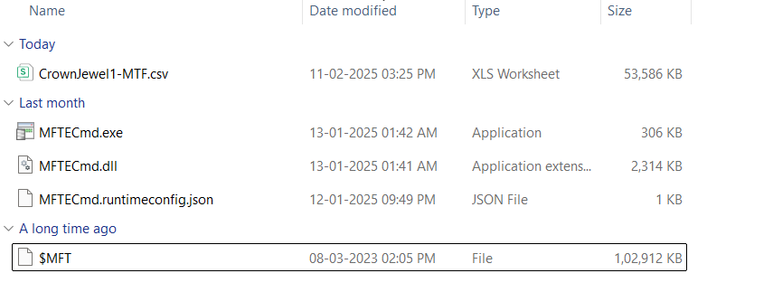

Now lets try to get the rest of the answers from here
I just filtered the csv file to ntds files and get to know that on the same day we have a mount on the disk
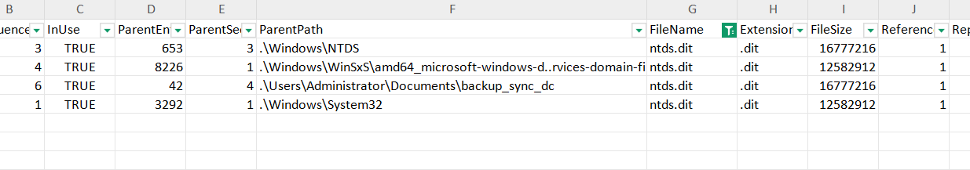
97945 | 6 | TRUE | 42 | 4 | .\Users\Administrator\Documents\backup_sync_dc | ntds.dit | .dit | 16777216 | 1 |  | FALSE | FALSE | FALSE | FALSE | FALSE | TRUE | Archive | DosWindows | 2024-05-14 03.44.22.8137562 |  | 2023-03-27 14.02.43.9320745 | 2024-05-14 03.44.22.8137562 | 2023-03-27 14.02.43.9320745 | 2024-05-14 03.44.22.8137562 | 2024-05-14 03.44.22.8449606 | 2024-05-14 03.44.22.8137562 | 16298064 | 489751221 | 833



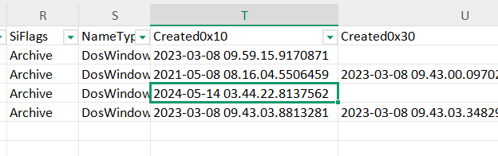


Here if I see in the below image when the ntds is dumped we get to see the Parent entry number of 42 we get to see the other dumped registery hive and the file size too

